Task 3: TLS Communication Inspection & Analysis
- and 2. Connect and Extract TLS Details using openssl s_client
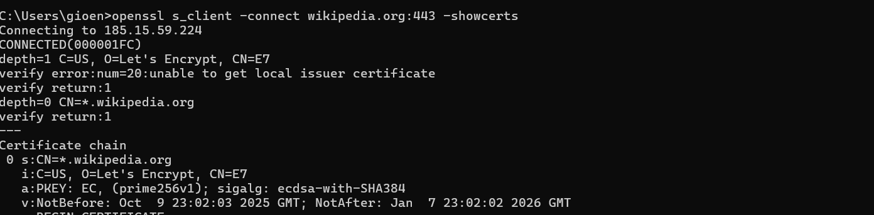
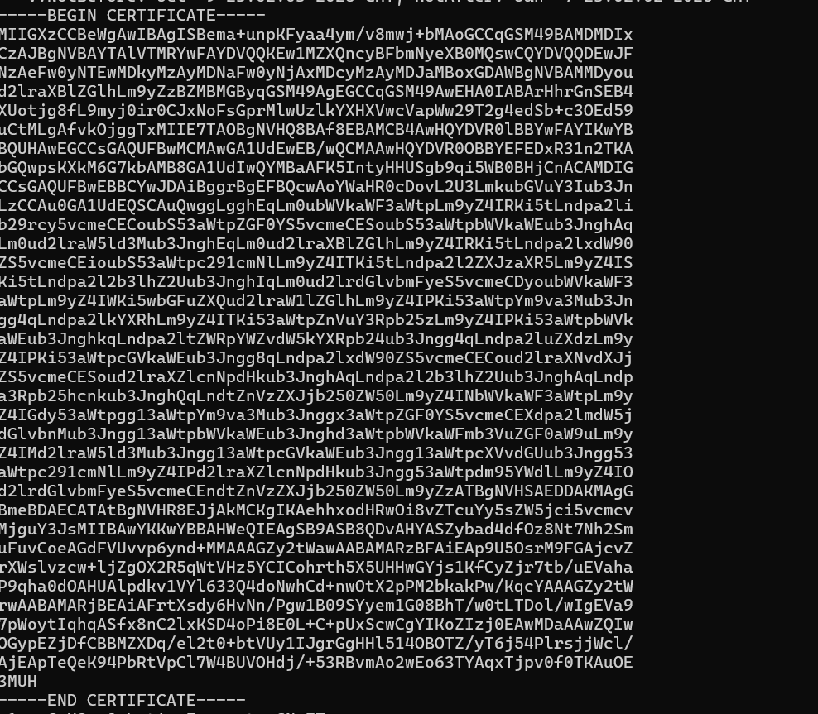
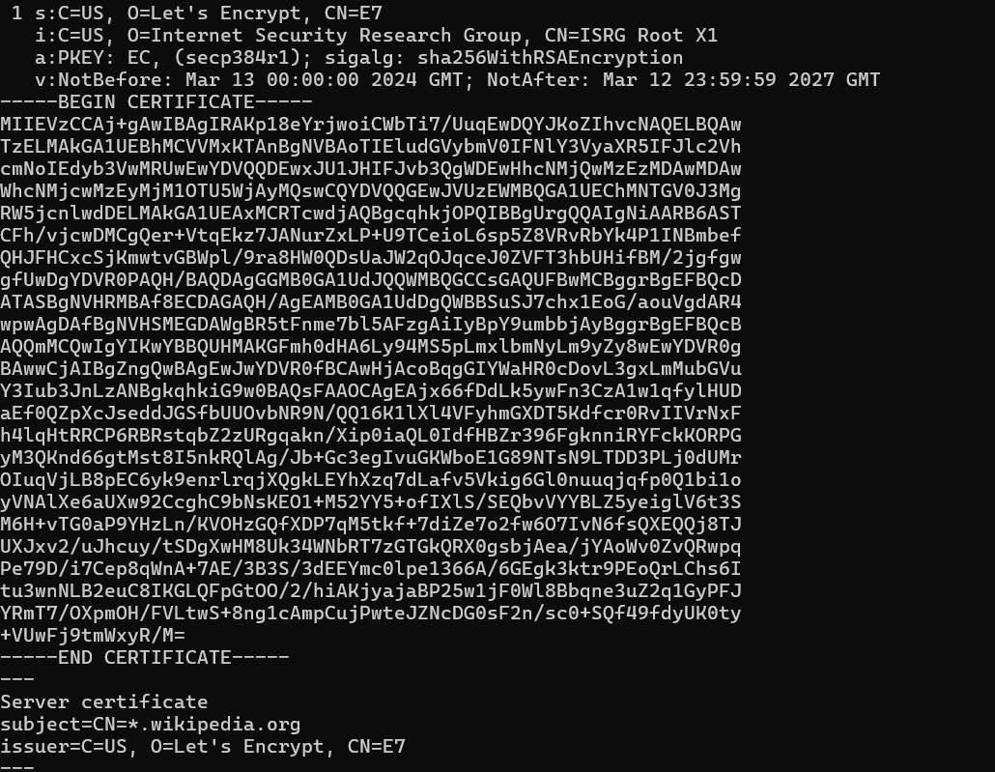
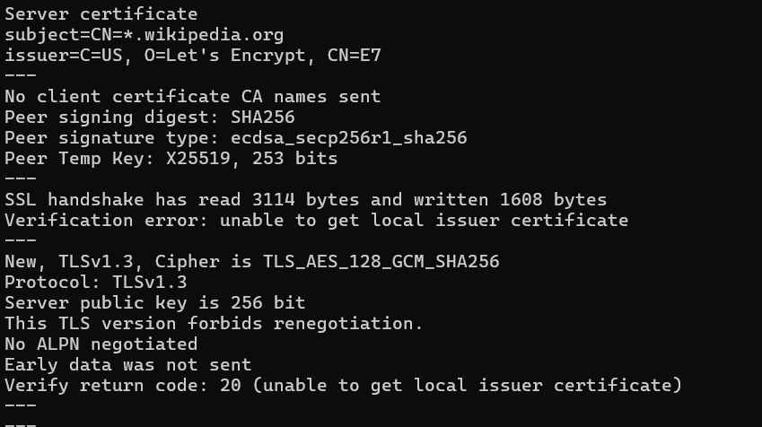
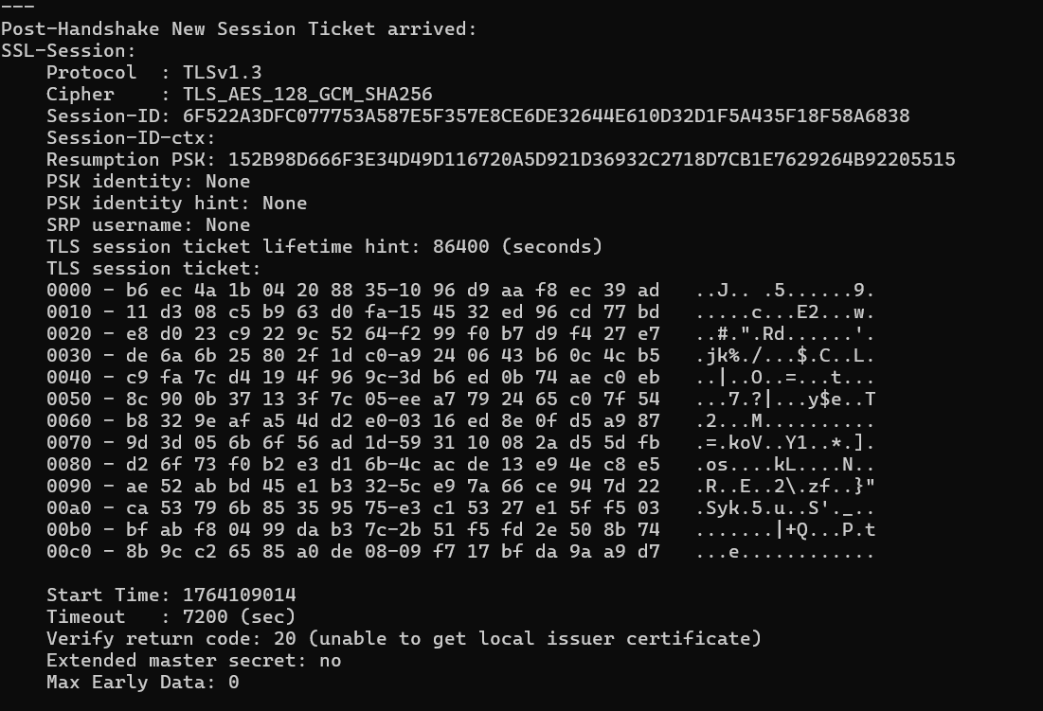
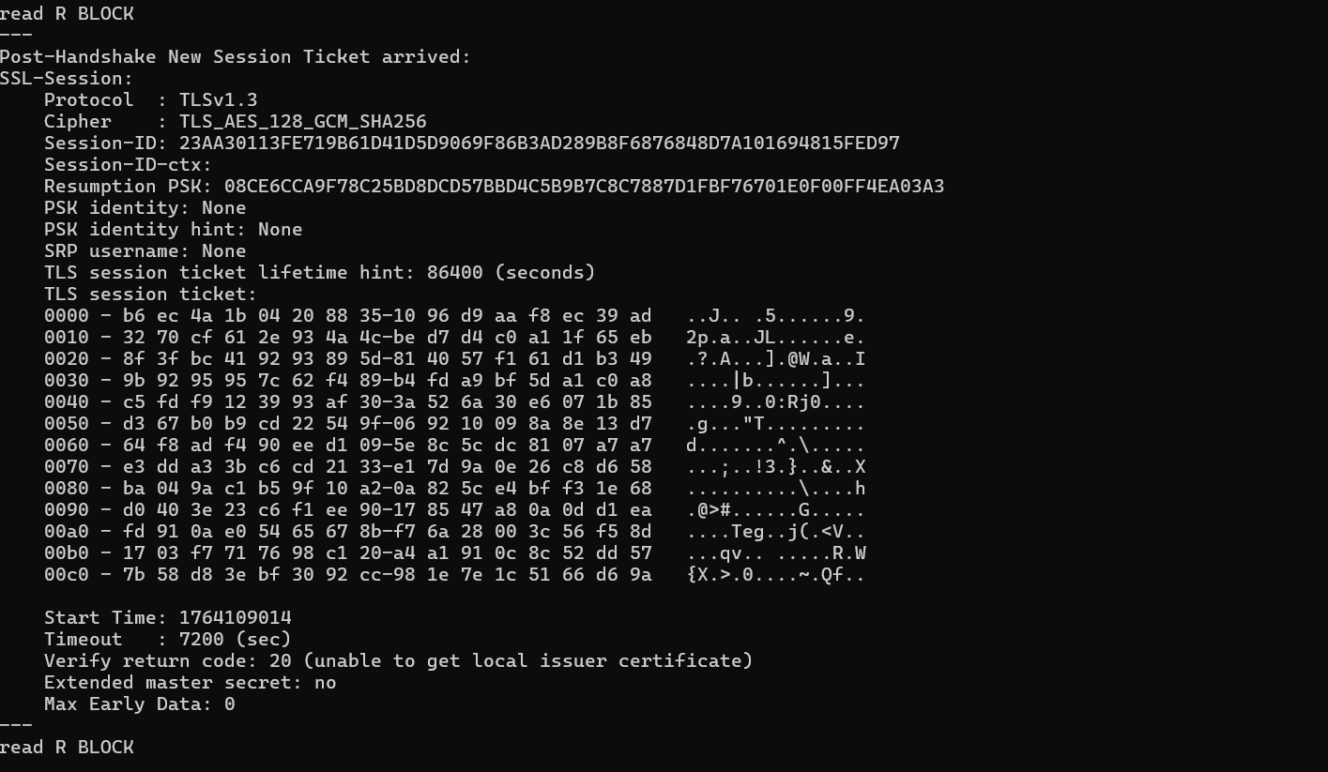

3 .Capture and Highlight TLS Handshake using Wireshark
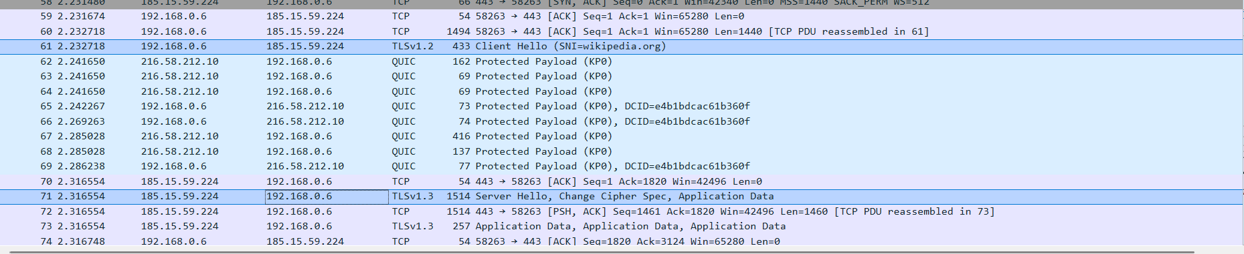
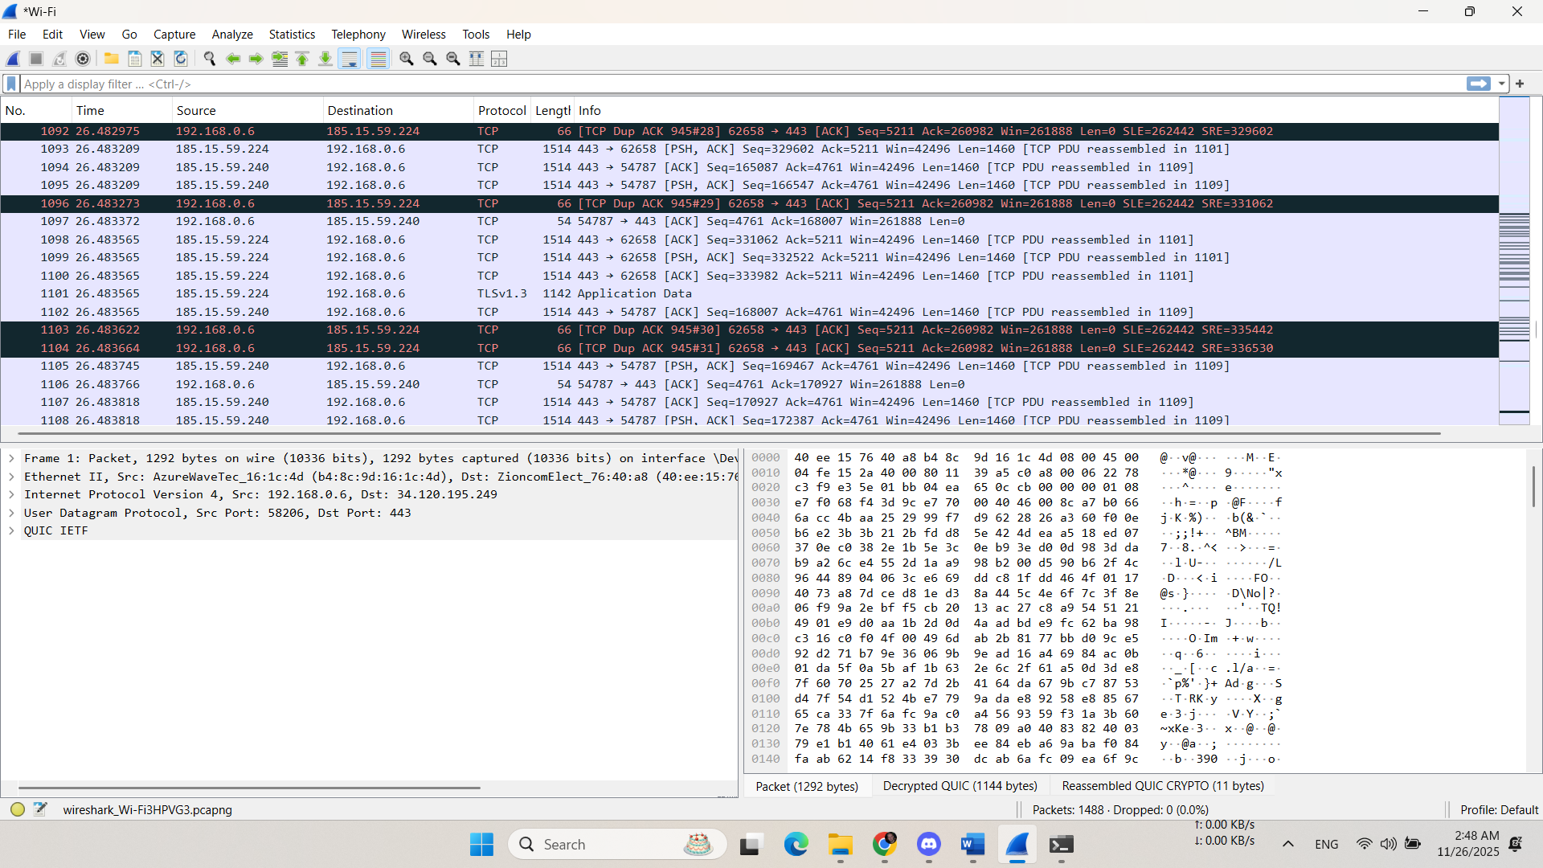

4. How TLS Provides Confidentiality and Integrity
Mechanism in TLS
Confidentiality
Provided by Symmetric Encryption (e.g., AES-256). During the handshake, the client and server agree on a Cipher Suite and derive a shared secret key. All application data transmitted after the handshake is encrypted using this fast symmetric key, making it unreadable to any third party who may intercept the traffic.
Integrity
Provided by Message Authentication Codes (MACs), typically using Hash Functions (e.g., SHA-256 or SHA-384 in modern cipher suites like GCM). For every data record sent, a MAC is calculated based on the data and the shared secret key. The receiver recalculates the MAC and compares it to the one sent. If they don't match, the data has been tampered with or corrupted during transmission, ensuring data integrity.

